January 19, 2017

Economic press contact
Dr. Edda Schulze
Corporate Press
Phone +49 201 177-2225
Fax +49 201 177-3030
edda.schulze@evonik.com
Specialized press contact
Mr. Yama Olumi
Global Communications Manager
Business Line Oil Additives
Phone + 1 215 706-5825
Fax +1 215 706 5801
yama.olumi@evonik.com

Evonik Industries AG
Rellinghauser Straße 1-11
45128 Essen
Germany
Phone +49 201 177-01
Fax +49 201 177-3475
www.evonik.com

Supervisory Board
Dr. Werner Müller, Chairman
Executive Board
Dr. Klaus Engel, Chairman
Christian Kullmann, Deputy Chairman
Dr. Ralph Sven Kaufmann
Thomas Wessel
Ute Wolf

Registered Office is Essen
Register Court Essen Local Court
Commercial Registry B 19474
New base oil from Evonik keeps wind turbines turning

- Evonik’s synthetic base oil VISCOBASE® 5-220 improves wind farm efficiency
- Approved by leading gearbox manufacturers
- Application in mining and steel industries also

Operators of wind energy farms place steep demands on the gear oil for their wind turbines: long oil drain intervals, sustained optimal viscosity of the oil over a wide temperature range, and maximum durability and long life for the gearbox. In VISCOBASE® 5-220, Evonik has developed a synthetic base oil that sets new standards in the field. As the critical key component of lubricants formulated to Evonik’s NUFLUX™ technology standard, it has, in short order, received the essential “thumbs up” from the key industrial gearbox manufacturers. With these critical approvals, the way is now open for other high-performance gear applications.

“Wind turbines are tough testing grounds for gearboxes and gear oils: they need to perform as long as possible in a maintenance-free state despite constantly changing weather conditions and temperatures, humidity, and peak loads during storms,” explains Sofia Sirak, Evonik’s Oil Additives Innovation Manager for North America. “Until now, the gear oils of choice have been synthetic formulations based on polyalphaolefins. But with VISCOBASE® 5-220, based on polyalkyl methacrylates, this could now change,” she adds.

Tests conducted by FZG, the international research center for gears and transmissions, are regarded as the industry standard. And Evonik’s VISCOBASE® 5-220 formulation has now passed the FZG bench test and earned a very important approval. More importantly, over the past two years, Evonik has shown that gear oils formulated to NUFLUX™ technology standards with VISCOBASE® 5-220 have a particularly long service life between fewer drain intervals. They improve energy efficiency by maintaining an optimal viscosity across an expanded range of operating temperatures – from cold to hot.

The VISCOBASE® 5-220 base oil is one component of the novel NUFLUX™ technology with which Evonik is making its formulation expertise available to its customers. More precisely, NUFLUX™ technology is the collection of products, formulation concepts and services that Evonik provides to customers in need of resource-efficient industrial lubricants.

“Now that both base oil and formulation technology have succeeded in the tests developed by the industry leaders in gearbox design and manufacturing,” explains Dr. Ralf Duessel, Senior Vice President and Managing Director of Evonik’s Oil Additives business line, “Evonik is now positioned for expansion into other applications, such as mining and steel production, which are two of the largest markets for industrial gear oils.”
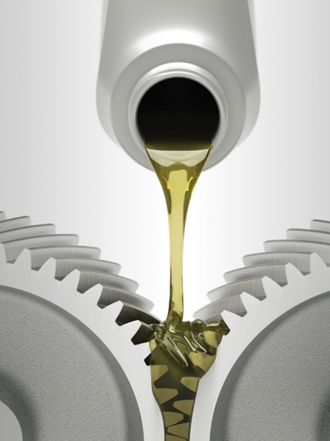

Caption picture 1:
Gear oils formulated to NUFLUX™ technology standards with VISCOBASE® 5-220 have a particularly long service life between fewer drain intervals.
(Source: Evonik Industries)

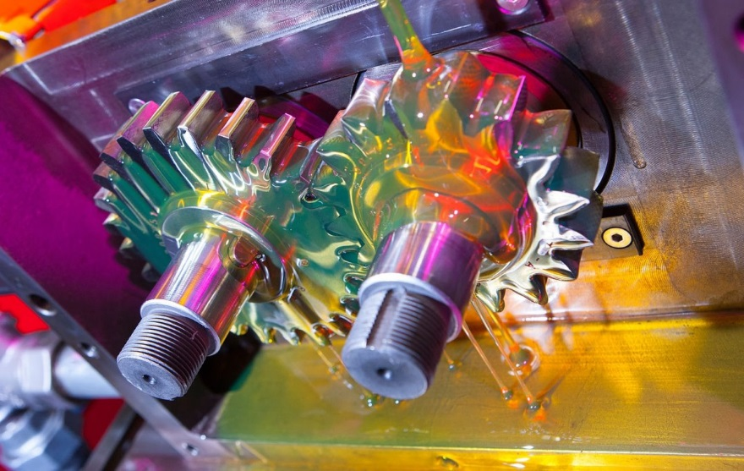
Caption picture 2:
Tests conducted by FZG, the international research center for gears and transmissions, are regarded as industry standard. VISCOBASE® 5-220 formulation has passed the FZG bench test.
(Source: Evonik Industries)

Company information
Evonik, the creative industrial group from Germany, is one of the world leaders
in specialty chemicals. Profitable growth and a sustained increase in the value of the company form the heart of Evonik’s corporate strategy. Its activities focus on the key megatrends health, nutrition, resource efficiency and globalization. Evonik benefits specifically from its innovative prowess and integrated technology platforms.

Evonik is active in over 100 countries around the world. In fiscal 2015 more than 33,500 employees generated sales of around €13.5 billion and an operating profit (adjusted EBITDA) of about €2.47 billion.

Disclaimer
In so far as forecasts or expectations are expressed in this press release or where our statements concern the future, these forecasts, expectations or statements may involve known or unknown risks and uncertainties. Actual results or developments may vary, depending on changes in the operating environment. Neither Evonik Industries AG nor its group companies assume an obligation to update the forecasts, expectations or statements contained in this release.

